Cryptography Laboratory Experiments (Python)

Experiment No: 1
Experiment Name: Caesar Cipher
Aim: To implement the Caesar Cipher technique for encryption and decryption using Python.
Algorithm:
- Read the plaintext.
- Read the key value.
- Encrypt each alphabet by shifting with the key.
- Decrypt by reversing the shift.
- Display the encrypted and decrypted text.
Code:
# Caesar Cipher
plain_text = input("Enter the plain text: ")
key = int(input("Enter the key value: "))
cipher_text = ""
for ch in plain_text:
if ch.isupper():
cipher_text += chr((ord(ch)-65+key)%26+65)
elif ch.islower():
cipher_text += chr((ord(ch)-97+key)%26+97)
else:
cipher_text += ch
print("Encrypted Text:", cipher_text)
decrypted_text=""
for ch in cipher_text:
if ch.isupper():
decrypted_text += chr((ord(ch)-65-key)%26+65)
elif ch.islower():
decrypted_text += chr((ord(ch)-97-key)%26+97)
else:
decrypted_text += ch
print("Decrypted Text:", decrypted_text)
Sample Input:
Hello world
4
Sample Output/Result:

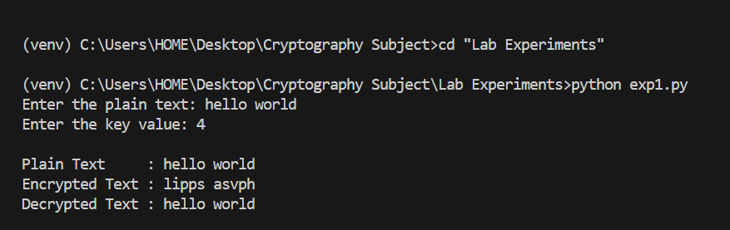

Experiment No: 2
Experiment Name: Playfair Cipher
Aim: To implement the Playfair Cipher substitution technique using Python.
Algorithm:
- Read the keyword.
- Generate the 5×5 key matrix.
- Prepare plaintext as digraphs.
- Apply Playfair rules.
- Display the ciphertext.
Code:
Refer to the Playfair Python program provided earlier in the conversation.
Sample Input:
Key: hooii
Plain Text: This is my world!!
Sample Output/Result: 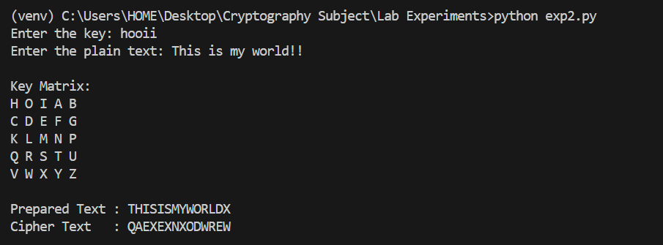

Experiment No: 3
Experiment Name: Hill Cipher
Aim: To implement the Hill Cipher substitution technique using Python.
Algorithm:
- Read a 3-letter plaintext.
- Convert letters to numbers.
- Multiply by the 3×3 key matrix.
- Take modulo 26.
- Decrypt using the inverse key matrix.
Code:
Refer to the Hill Cipher Python program provided earlier in the conversation.
Sample Input:
ACT
Sample Output/Result:
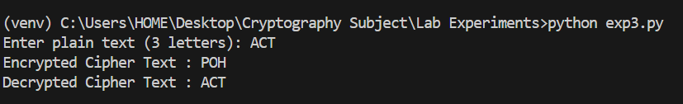

Experiment No: 4
Experiment Name: Vigenere Cipher
Aim: To implement the Vigenère Cipher using Python.
Algorithm:
- Read plaintext and keyword.
- Repeat the keyword.
- Encrypt using modular addition.
- Decrypt using modular subtraction.
- Display the results.
Code:
Refer to the Vigenère Cipher Python program provided earlier in the conversation.
Sample Input:
Hello This is Pramith
key
Sample Output/Result:

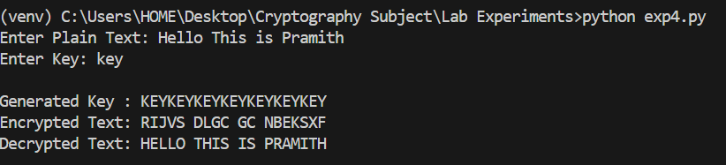

Experiment No: 5
Experiment Name: Rail Fence Cipher
Aim: To implement the Rail Fence Cipher using Python.
Algorithm:
- Read the plaintext.
- Form ciphertext from even and odd indexed characters.
- Split ciphertext.
- Merge alternately.
- Display decrypted text.
Code:
Refer to the Rail Fence Cipher Python program provided earlier in the conversation.
Sample Input:
I want to meet you
Sample Output/Result:

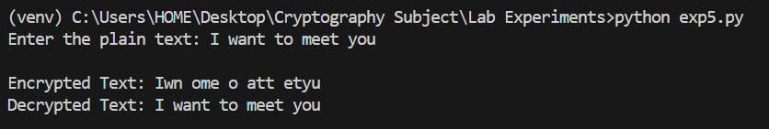

Experiment No: 6
Experiment Name: DES
Aim: To implement the Data Encryption Standard (DES) algorithm using Python.
Algorithm:
- Read the plaintext.
- Read an 8-byte key.
- Encrypt using DES.
- Decrypt using the same key.
- Display the results.
Code:
from Crypto.Cipher import DES
from Crypto.Util.Padding import pad, unpad
key=input("Enter 8-character key: ").encode()
plaintext=input("Enter the plain text: ")
cipher=DES.new(key, DES.MODE_ECB)
encrypted=cipher.encrypt(pad(plaintext.encode(), DES.block_size))
print(encrypted.hex())
print(unpad(cipher.decrypt(encrypted),DES.block_size).decode())
Sample Input:
Bujjihii
This is Cryptography
Sample Output/Result:
